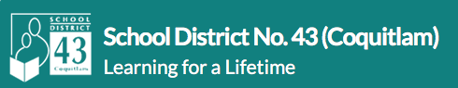

Adapted Sport Afterschool Program.

Through the development of a community partnership between Unique Get Together Society, Moresports, and School District 43, we are proud to introduce an all-access, all-abilities after school program for basketball at Minnekhada and Como Lake Middle Schools. Students from ANY District 43 Elementary and middle schools, ages 6-14 are welcome to attend. Registration can be done online, by following the link to SD43 Community Connections Registration site and selecting the program you want.

Click here to register

The program provides youth workers, coaches and mentors to meet the needs of the registrants. The focus is on social-emotional development of participants, and connectivity for kids and parents involved. Coaches will teach basketball skills, gameplay and team pride. We will provide an uniform for all kids.

Partnership Groups: School District 43 Community Connections is committed to Community Development through collaborative efforts. In this project, we are lucky to be working with two amazing contributors to children and their families. We are excited about this project and look forward to doing even more to improve access to sport in the future.

Unique Get Together Society: https://www.uniquegettogethersociety.com/about-us/

Moresports: https://moresports.org/about/

